PARISH NEWS
Sunday 21 April 2024
The Fourth Sunday of Easter

 |  |  | TODAY’S CELEBRATION
Welcome to this celebration of the Mass. Thank you for being here.
THE FOURTH SUNDAY OF EASTER
Year B in the Three-Year Lectionary Cycle
 |  | Principal Celebrant |  | The Reverend Dr. Linda Fiske
 |  | Homilist |  | The Reverend Dr. Linda Fiske
 |  | Organist |  | Tony White
 |  | Cantor |  | James Allen
 |  | MUSIC
 |  | HYMNS (in Mass book) |  | Number and First Line | Tune
 |  | Entrance Hymn |  | NEH 125– Alleluia! Alleluia! Alleluia! | O Filii et Filliae
 |  | Offertory Hymn |  | NEH 104 – At the Lamb’s high feast | Salzburg
 |  | Hymn after Communion |  | NEH105 – Christ the Lord is risen again | Württemburg
 |  | Final Hymn |  | NEH 120– Thine be the glory ….. | Maccabaeus
 |  | Mass Setting |  | Missa d’Angelus | Cox and Skinner
 |  | Motet
 |  | READINGS
 |  | First Reading |  | Acts 4: 7-12 | Rena Pritchard
 |  | Responsorial Canticle |  | Psalm 118:1+8-9, 21-23, 26+28-29
 |  | Second Reading |  | 1 John 3: 1-2 | Andrew Buchanan
 |  | Gospel |  | John 10: 11-18
 |  | Prayers of the Faithful |  |  | Rena Pritchard
 | Eucharistic Assistant |  |  |  | Bryn Jones
DONATING MADE EASY
DIGITAL GIVING
No cash on you? Use the new tap-on facility beside the collection basket or this QR Code…. è
DIRECT TRANSFER REMINDER
If you use direct transfer, please check it is still operative as sometimes it expires and your desire to give to the work of God’s church can be overlooked. BSB 013275 Acc No. 0070-86265 Acc Name Church Wardens AC
ENVELOPE SCHEME
Envelopes imprinted with the date of each Sunday assist with your weekly sacrificial gift. Ask Rod Conn or Gary Simmons if you would like a set of these envelopes.
RESPONSE FOR THE PSALM
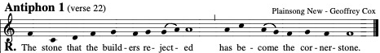
NEWS AND NOTICES
If you need a priest, please contact Linda Fiske on 0408 561 964 or lindalfiske@gmail.com. If you are unable to get hold of Linda, please contact Rod Conn on 0419 565 453 or rodconn@bigpond.net.au

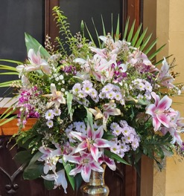 | Flowers in the Church  Thank you to everyone who donated towards the flowers in the church for Easter. It is wonderful to have flowers back in the church. As we progress through Easter, if you would like donate for flowers, as a particular intention or in memory of someone, there are envelopes at the back of the church, or use the tap-on device or the QR code.
NOTICES – CALENDARS
 |  |  |  |  | PARISH LITURGIES THIS WEEK
 |  | Day |  |  |  |  | Saint’s Day |  | Liturgy |  |  | Time
 |  | Tuesday 23 April |  |  |  |  | Saint George |  | Mass |  |  | 12pm
 |  | Thursday 25 April |  |  |  |  | Saint Mark |  | Mass |  |  | 7pm
 |  |  |  | FORTHCOMING MASSES AND PARISH EVENTS
 |  | MEETINGS and SPECIAL OCCASIONS
 |  | CHORAL MASSES AND FORTHCOMING EVENTS
 |  | FRIENDS OF SAINT MARKS EVENTS
 | NEXT SUNDAY’S LITURGICAL MINISTRIES AT SOLEMN MASS
28 APRIL – THE FIFTH SUNDAY OF EASTER
Year B in the Three-Year Lectionary Cycle
 |  | Presider |  |  |  | The Reverend Dr. Linda Fiske
 |  | Homilist |  |  |  | The Reverend Dr. Linda Fiske
 |  | First Reading |  |  |  | Acts 9:26-31 |  |  |  | Robyn Gunther
 |  | Responsorial Canticle |  |  |  | Psalm 23:25b-26, 27+29, 30-31
 |  | Second Reading |  |  |  | 1 John 3:18-24 |  |  |  | Tony White
 |  | Gospel |  |  |  | John 15:1-8
 |  | Prayers of the Faithful |  |  |  |  |  |  |  | Tony White
 |  | Eucharistic Assistant |  |  |  |  |  |  |  | Robyn Gunther
THE FABRIC OF OUR LIVES

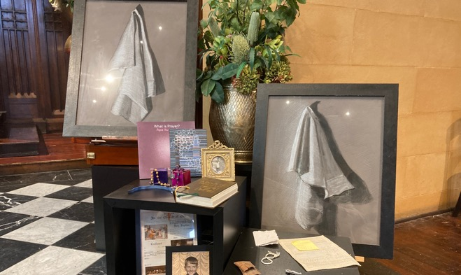

Beginning with Lent and carrying through Eastertide we have been building an installation of The Fabric Of Our Lives. Mother Linda has called us to consider the warp and weft of life that bring both the positive and the negative aspects of experience. It is in grounded and complex weaving of daily living God interacts with us. Parishioners have been, and are still invited to bring items that are meaningful to them to have them blessed and censed as part of our ritual at Sunday morning Mass. As these important Easter days continue, the opportunity for learning and growth calls to us. You might like to consider participating in this installation as this week’s sermon considers the theme of Easter Faith.

PRAYER FOR A NEW INCUMBENT
Bountiful God, give to this parish a faithful pastor who will faithfully speak your word and administer your sacraments; an encourager who will equip your people for ministry and enable us to fulfil our calling. Give to those who will choose, Louise, Rod and Rena, wisdom, discernment and patience, and to us give warm and generous hearts, for Jesus Christ’s sake. Amen.
SAINT MARK’S DAY - 25th APRIL

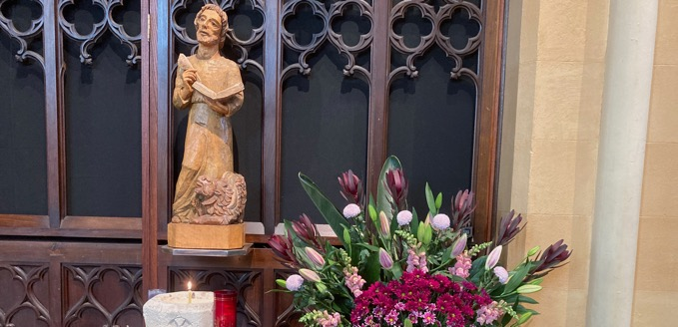

Thursday 25th April is the day of Saint Mark, our Patron Saint, and we will be celebrating Mass at 7pm on that day. Please join us as we acknowledge Saint Mark in the Sacrament at the altar and reflect on him in our lives, as a parish committed to fellowship, love and outreach to the marginalised in our community.

STATEMENT ON PEACE IN THE HOLY LAND

We, the Bishops of the Anglican Church of Australia, gathered at Bendigo on Thursday 21st March 2024, unanimously affirm the following statement.
‘As we enter into Holy Week, we lament the suffering due to the ongoing war in the Holy Land. In the spirit of Jesus Christ who said, “Blessed are the peacemakers” we pray for a just and lasting peace, for the release of all hostages, and for urgent aid to be delivered to civilians in Gaza. In praying for peace in the Holy Land, we particularly pray for strength for our Christian brothers and sisters in Israel, Gaza and the West Bank who, under the shadow of war, prepare to commemorate the death and resurrection of our Lord and Saviour, Jesus Christ. Anglicans across Australia are already praying for peace in this time. We know that this prayer will be shared in every church this Holy Week and Easter. As we lament the ongoing suffering, we condemn antisemitism and anti-Muslim sentiment which is on the rise in our own society. We appeal to all Australians to treat others as they would like to be treated, and we commit ourselves to work with other faith leaders for the common good for all Australians.’
PARISH INFORMATION
HISTORY
Saint Mark’s Anglican Church was opened on 21 January 1855, the foundation stone having been laid on 1 July 1853. A school was established here in 1849. There are six buildings on the Saint Mark’s site built between 1891 and 1926. The Church is classified by the National Trust and underwent a major restoration in the 1990s.
ACKNOWLEDGEMENT OF COUNTRY
We acknowledge the traditional custodians of this Land, the Wurrundjeri people of the Kulin Nations. We pay our respects to their elders past and present.
OUR VISION
The Parish of Saint Mark the Evangelist, Fitzroy, identifies as an inclusive and diverse community of faith and action, founded on the Anglican Catholic tradition, with a strong commitment to the beauty of the liturgy, openness to learning and growth in faith, and the visibility of the church in daily life through hospitality, care, and outreach in the local community. It makes its presence felt in time and place, in the human community of inner-city Fitzroy and across time and space through emerging technologies and different platforms. Our Priorities are:
- Catholic Liturgy, Spirituality and Theology
- Learning and Leadership Development
- Hospitality and Pastoral Care
- Community Engagement and Outreach
- Co-operation and Partnership
- Stewardship and Resources Management
COMMUNITY PROGRAMS
SAINT MARKS COMMUNITY CENTRE |  | SAINT MARKS RECYCLED
250 George Street, Fitzroy  A partnership with Anglicare Victoria to provide support to those experiencing homelessness |  | 298 Smith Street, Collingwood  Our opportunity shop provides quality recycled goods. Supports the work of our Community Centre
WHERE TO FIND US
www.stmarksfitzroy.com
SUNDAY MASS – Always at 9.30 am and live streamed on YouTube
250 George Street (Cnr of Moor Street) Fitzroy |  |  | PO Box 124 Fitzroy Victoria 3065
Acting Vicar: The Reverend Dr Linda Fiske
 | Tel: 0408 561 964 | Email: lindalfiske@gmail.com

